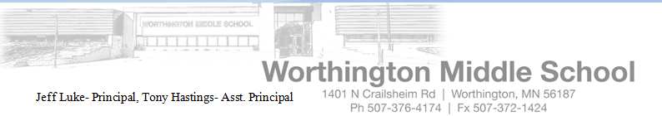
As a fourth grader, your child finally has the opportunity to do what so many successful students have done before them, Be Part of the Band! We would like you to consider having your child participate in the District #518 band program in the Worthington Middle School. The study of music could be one of the most valuable steps in your child’s education. During the next few weeks, I will be meeting with all fourth grade students in general music classes to acquaint them with the band and the various instruments available. At the completion of this process, you will receive a second letter stating the recommended instrument for your child.
March 1, 2014

We know that many of you have a child in orchestra. I am pleased to inform you the schedule at the middle school allows your child to participate in band, orchestra and classroom music.

Your involvement with your child in the beginning band program is extremely important. To help you better understand the program, we are hosting an instrument fair in the Worthington Middle School band room Tuesday, April 29 from 2:30-8:30. The purpose of the open house/meeting is to outline District 518’s Band Program, discuss the benefits of band, and the relationship among student, parent, and teacher and to answer any questions you have regarding the Band Program and your child. Parents can also rent an instrument through a music store and sign-up for summer band.

So that we can begin to evaluate the level of interest among our fourth grade class, we ask that you take a moment to return the form below to a music teacher (Moe, Mammen, Dwan, VanWesten, Jenson) by March 21. Save the upper portion of this letter for your reference. Should you have questions that need to be answered prior to this meeting, do not hesitate to call the school at 376-4174 ext. 4173 or email Jeanette.jenson@isd518.net and I will get back to you as soon as possible.

5th through 8th grade band will be providing a Summer Band Program during the weeks of June 2 to June 13 at Worthington Middle School. All new band members are encouraged to participate in the Beginner Band Program this summer. This is a great time to learn and instrument and I can’t wait to get started!

Thank you in advance for your cooperation. I look forward to seeing you on Tuesday, April 29.
Sincerely,
Jeanette Jenson, 5th grade Band Director, Worthington Middle School
_______________________________________________________________________________________________
___ I am interested, and my child and I will attend the recruiting night on April 29 at WMS.
____I am interested, but we cannot attend the recruiting night. Mrs. Jenson will call to arrange a conference.
Please include the best way to reach you (h)__________________or (w) ____________________________
___ My child is not interested in participating in the beginning band program.
(First) (Last)
Child’s name________________________________________________________ Classroom teacher_____________

Parent’s name___________________________________Phone number _______________________________
My child is interested in playing the following instruments:

First choice_____________________ Second choice____________________ Third choice______________________

Parent’s signature_____________________________Comments:
*Summer band participation fee- $50.00 payable to District 518

